Advance Machine Learning (WOA7015)
Alternative Assessment
2025/2026 Sem 1

A Comparative Study of CNN Baseline Classifier and LLM-Based Model for Medical Visual Question Answersing

Group ZZ

NAME | MATIRX NO.
ZHONG JUN PEI | 24214748
ZOU TING | 24201617

ABSTRACT
Introduction: XXX
Method: XXX
Results: XXX
Conclusion: XXX
Word Count: XXX words (max 300 words)
Keywords: 5-6 Keywords

INTRODUCTION

Sub-heading (if required)

METHODS

This section outlines the experimental setup used in this research to establish a reproducible baseline and a VLM model for medical visual question answering (VQA). The details provided include dataset preparation, model architecture, training procedures, and evaluation metrics.

Dataset
In this study, we used the VQA-RAD dataset for medical visual question answering. VQA-RAD consists of 315 radiology images (X-rays and CT scans) and 2,247 clinician-verified question–answer (QA) pairs. Compared with datasets that require external medical knowledge (e.g., SLAKE), VQA-RAD focuses on pure visual questions, where answers can be inferred directly from the image content. This design makes the dataset suitable for evaluating the visual representation learning and vision–language alignment capabilities of the model.
The questions include both closed-ended and open-ended types. Closed-ended questions account for 57.7% of the dataset, while open-ended questions account for 42.3%. The questions cover multiple medical aspects, such as abnormality presence, anatomical location, and imaging modality. Notably, approximately 19.6% of the questions are duplicates, which requires careful evaluation to reduce potential textual bias.
For model training and evaluation, the dataset was randomly split into training and test sets with a ratio of 80:20. All images were resized to $\text{224×224}$pixels and normalized to match the input requirements of the pre-trained CLIP image encoder. Text data were tokenized and formatted into a causal language modeling prompt (e.g., “Question: [Q] Answer: [A]”) to support generative learning.
Table 1 Statistics of the VQA-RAD Dataset
Item | Description
Number of images | 315
Image modalities | X-ray, CT
Number of QA pairs | 2,247
Closed-ended questions | 57.7%
Open-ended questions | 42.3%
Duplicate questions | 19.6%
Train / Test split | 80% / 20%

Baseline Model Architecture
This section will explain the architecture diagram of the baseline system, which is divided into four modules: Data Preprocessing, Data Transformation and Loading, Model Building, and Training Pipeline. Figure 1shows schematic diagram for specific functions. The following sections provide explanations for each individual module and the final training model.
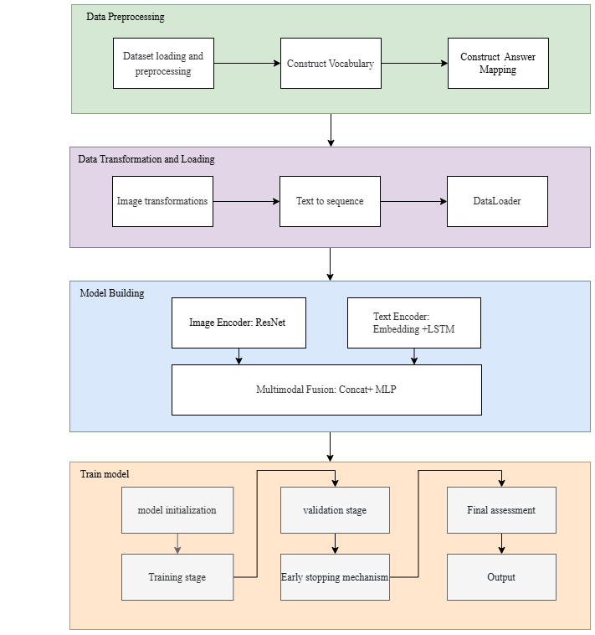
Figure 1 the architecture diagram of the baseline system

Data Preprocessing
Dataset preprocessing is divided into three steps: dataset loading and preprocessing, vocabulary construction, answer mapping construction.

First, load and preprocess the dataset. Read the data from the original file VQA_RAD Dataset Public.json, which is in JSON format. Each sample contains fields such as image_name (image file name), question (questions related to medical imaging), answer (corresponding answer text), and answer_type (question type, such as OPEN/CLOSED).
During the data cleaning stage, check and remove the samples with missing key fields (image_id, question, answer). After statistics, there are no missing samples in the current dataset. Subsequently, the dataset was randomly divided into the training set, validation set and test set in ratios of 70%, 15% and 15% respectively, with the random seed fixed at 42.
The distribution of question types in each dataset after division is shown in the Table 2.
Table 2 Question Type Distribution
Question Type | Train | Validation | Test
CLOSED | 920 (58.4%) | 195 (57.9%) | 184 (54.6%)
OPEN | 654 (41.6%) | 142 (42.1%) | 153 (45.4%)

The purpose of vocabulary construction is to convert text-based questions into numerical sequences that machines can process, providing standardized input of fixed dimensions for the model. The vocabulary list is constructed solely based on the question texts in the training set. During the construction process, first uniformly convert the problem text to lowercase and separate words by spaces. At the same time, remove punctuation marks and set the minimum word frequency threshold min_freq=2. Low-frequency words below this threshold will be regarded as unregistered words. In addition, add the following special tags: <PAD> (filler, ID: 0), <UNK> (unlogged word, ID: 1), <SOS> (sentence beginning tag, ID: 2), and <EOS> (sentence end tag, ID: 3). After statistics, the total number of words in the training set after removing duplicates is 2,158, and the size of the final constructed vocabulary list (including special tags) is 1,284. The statistical results of some high-frequency words are shown in the following Table 3.
Table 3 Top 5 high-frequency words
Rank | Word | Occurrences
1 | the | 1,216
2 | is | 1,048
3 | what | 404
4 | this | 383
5 | in | 337

The purpose of constructing the answer mapping table is to convert text answers into category labels in classification tasks, achieving standardized mapping from open-domain answers to fixed category spaces. To prevent data leakage, the mapping table is constructed only based on the answers in the training set, treating each unique answer as an independent category. Since the test set may contain answers that do not appear in the training set, an additional <UNK> (unknown) category is added to the mapping table to uniformly map these unseen answers, thereby ensuring that all samples have valid labels and truly reflect the model's ability to handle new answers. The statistical results show that the number of unique answers in the training set is 1,412, and the distribution of answers presents a distinct long-tail characteristic with a high degree of category imbalance. The statistics of high-frequency answers are shown in Table 4.
Table 4 Top 5 high-frequency answers
Rank | Answer | Occurrences
1 | No | 335
2 | Yes | 262
3 | yes | 168
4 | no | 81
5 | Axial | 19

Data Transformation and Loading
Data Transformation consists of two parts: Image transformations and text serialization.
Image transformations process first uses resize(224, 224) to unify the image size, and then normalizes with mean (0.485, 0.456, 0.406) and standard deviation (0.229, 0.224, 0.225) to convert the image pixel values to a nearly normal distribution. Finally, a normalized image tensor with a structure of (3, 224, 224) is obtained.
Text serialization is only applied to problem text. Set the maximum sequence length max_seq_len=25 to unify the lengths of all questions: sequences shorter than 25 words are filled with <PAD>, and sequences longer than 25 words are truncated with the first 25 words. Each word is mapped to the corresponding ID according to the vocabulary list. Words that do not appear in the vocabulary list are mapped to <UNK> (ID: 1). The retention of the first 25 words during truncation is based on the assumption that key information in medical problems is usually located at the beginning. The answers in the dataset have been converted into individual category ids through the answer mapping table and can be directly used as classification labels without the need for serialization processing.
After the data conversion is completed, an image existence check will be conducted. If the image is found to be missing, replace it with a zero tensor and log it. At the same time, normalize the answer type to CLOSED or OPEN.
DataLoader converts the original dataset into a batch iterable data stream, providing standardized and efficient data supply for model training. The configuration of the baseline model is as follows: the number of samples in each batch is 32, and the number of loading processes is 2 (when using a GPU). Among them, the shuffle parameter of the training dataset is set to true to ensure that the data order is randomly shuffled in each training epoch to prevent overfitting, set the shuffle parameter of the validation dataset and the test dataset to false to facilitate tracking of model performance and ensure the reproducibility of results.

Model Building(MedVQA_ResNet_LSTM)
The overall architecture of MedVQA_ResNet_LSTM is a dual-stream fusion network: it uses ResNet50 as the image encoder for visual feature extraction, Embedding + LSTM as the text encoder for semantic feature extraction, and finally completes multimodal decision-making through the MLP fusion classifier.
ResNet is a deep convolutional neural network specifically designed for image data processing, with its primary task being to extract features from images. After preprocessing the input image of VQA-RAD, ResNet extracts the high-level image features, and the output high-dimensional features will be transferred to the fusion module.
LSTM is a recurrent neural network (RNN) used to handle sequential data, such as text questions (for example, "What disease is this?"). And extract semantic features from it.
The text input into LSTM first converts the words into vector representations through the embedding layer and processes them into fixed-length sequences.
After the image and text features are extracted respectively, they enter the feature fusion module. The fusion process is divided into two steps: First, perform combination, directly combine the image features and text features into a joint feature vector, thereby increasing the feature dimension; Then, MLP (Multi-Layer Perceptron) is used for nonlinear transformation. Through several fully connected layers, high-order feature extraction is carried out on the concatenated joint features, and finally the classification result is output.
The above is the architecture design of the baseline model.

Training Pipeline
The training and validation of the model are implemented based on the PyTorch framework and adopt the classic training-validation iterative strategy. After the initialization is completed, in each training epoch, the model first receives the training data for forward propagation to calculate the prediction result, then uses the Cross Entropy Loss function to calculate the prediction error, and updates the model parameters through error backpropagation. Finally, evaluate the model on the validation set and record the losses and other performance metrics. To prevent the model from overfitting during the training process, we introduced the early stopping mechanism. During the validation phase, the performance of the model is judged by monitoring the validation loss: if the validation loss does not improve for five consecutive cycles (with the patience value set to 5), the training will automatically stop, thereby reducing the training time and improving the generalization ability of the model. The objective of training is to enhance the performance of the validation set while reducing its loss. After each round of training, the system will save the weights of the model with the best current performance to ensure that the model with the best effect can be selected in the end. Figure 2 shows the detailed process of the training-validation iteration strategy and the early stop mechanism.
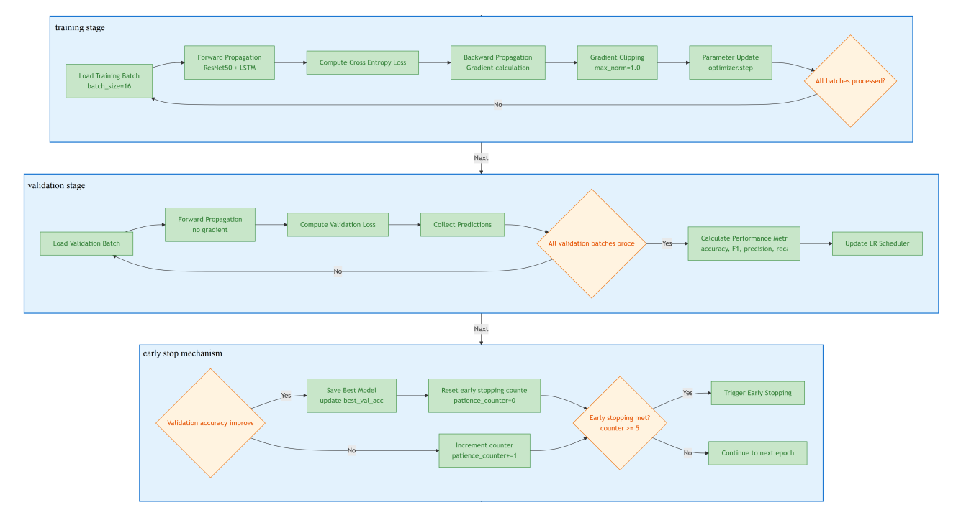
Figure 2 Process of the training-validation iteration strategy and the early stop mechanism
The key hyperparameters used during the training process are as follows:
Batch Size: Set to 16 to balance training efficiency and GPU memory usage.
Learning Rate: The initial learning rate is 0.0001. During training, a learning rate attenuation strategy based on the performance of the validation set (ReduceLROnPlateau) is adopted to dynamically adjust the learning rate.
Epochs : Set to 30 cycles.
To comprehensively evaluate the model's performance, we adopt the following metrics during the training and validation phases:
Cross-entropy loss: As the primary optimization objective, it measures the difference between the model's prediction and the true label.
Accuracy: Evaluate the classification performance of the model on the validation set.
F1-Score and Precision: A more comprehensive measure of a model's classification performance on imbalanced datasets.

Generative Model(Sonsbeek et al.) Architecture
Our model architecture follows the prefix-based vision–language framework proposed by Sonsbeek et al. (Sonsbeek et al., 2023) for medical visual question answering. The model consists of three main components: a pre-trained CLIP image encoder, a pre-trained GPT-2 language model, and a lightweight trainable mapping network that aligns visual and textual representations.
In this framework, a medical image is first encoded by a frozen CLIP image encoder (ViT-B/32) to obtain a global visual feature. This visual embedding is then projected by a mapping network, composed of two fully connected layers with a ReLU activation function, into a sequence of visual prefix tokens. The generated visual prefixes are concatenated with the token embeddings of the question–answer prompt and jointly fed into the GPT-2 model for autoregressive answer generation.
Consistent with the design in Sonsbeek et al., both the CLIP encoder and the GPT-2 model are kept frozen during training to reduce computational complexity and mitigate overfitting on the small-scale VQA-RAD dataset. Only the parameters of the mapping network are optimized using a causal language modeling objective. The loss is computed exclusively on the textual tokens, while the visual prefix tokens are masked, encouraging the model to learn effective cross-modal alignment without disrupting the pre-trained language modeling capability.
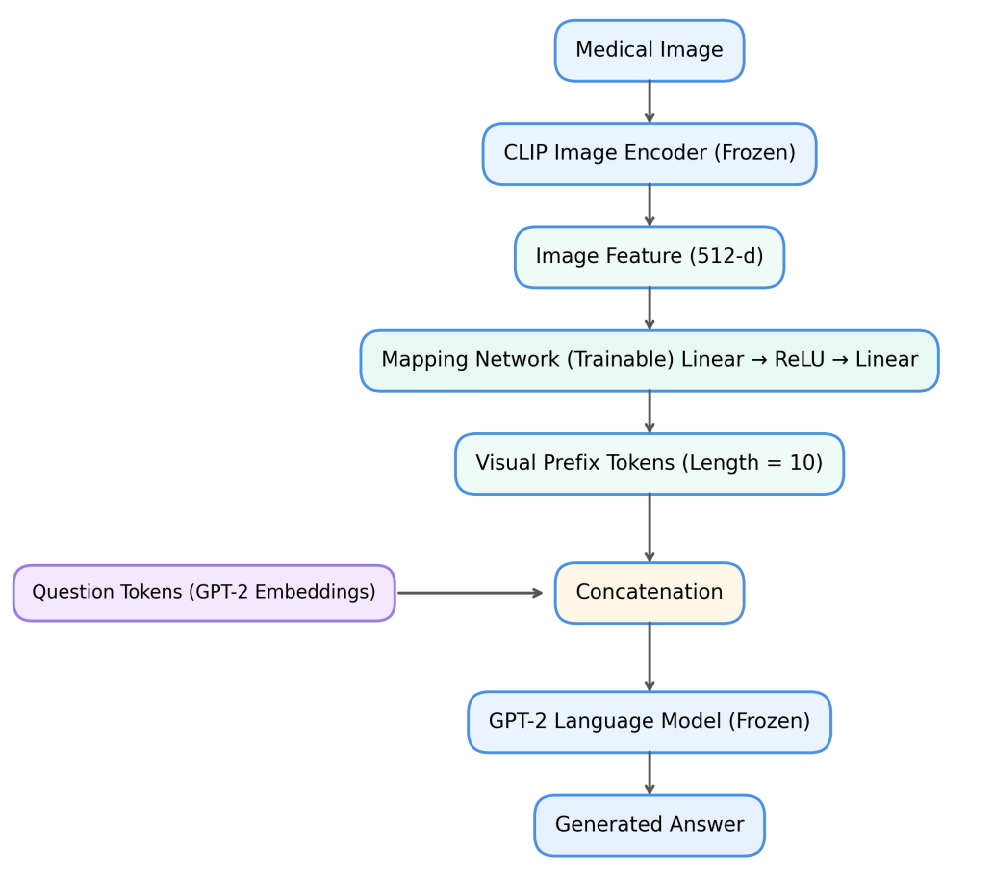
Figure 3 Overview of the prefix-based MedVQA architecture adopted in this study, following the framework proposed by Sonsbeek et al. (Sonsbeek et al., 2023).

Evaluation Metrics
To ensure a rigorous and fair assessment of model performance on the VQA-RAD dataset, this study adopts a set of evaluation metrics that account for both closed-ended and open-ended question types. Given the heterogeneous nature of Med-VQA tasks—ranging from binary diagnostic decisions to free-form clinical descriptions—no single metric is sufficient to fully capture model behaviour. Instead, a combination of classification-based and generation-oriented metrics is employed, following established practices in prior Med-VQA literature.
For closed-ended questions, where answers correspond to a fixed and finite label set (e.g., presence or absence of an abnormality), model performance is primarily evaluated using accuracy. As the baseline model formulates Med-VQA as a classification problem over a predefined answer pool, accuracy provides a direct and interpretable measure of diagnostic correctness. It is also the most commonly reported metric in VQA-RAD benchmarks, enabling meaningful comparison with existing studies.
To complement accuracy, threshold-independent diagnostic discrimination metrics are additionally considered. AUC-ROC is used to assess the model’s ability to distinguish between positive and negative clinical conditions across varying decision thresholds, while AUC-PRC offers further insight under class-imbalanced settings, where positive cases are relatively rare. Although these metrics are particularly informative for binary disease detection tasks, they are treated as supporting indicators in this study. The primary quantitative comparison for closed-ended evaluation remains accuracy, in order to maintain consistency with the evaluation of generative models.
In contrast, evaluating open-ended questions presents a fundamentally different challenge. Clinically correct responses may be expressed using diverse yet equally valid linguistic forms, making strict label matching insufficient. To address this, a multi-dimensional evaluation strategy is adopted to capture both diagnostic correctness and linguistic quality.
For short, determinate answers such as anatomical locations or categorical descriptors, exact match accuracy is employed. In addition to strict matching, a soft exact match variant is applied by normalizing generated outputs through lowercasing and punctuation removal. This approach avoids penalizing superficial formatting variations while preserving strict clinical validity.
For longer, free-form responses, Bilingual Evaluation Understudy (BLEU) serves as the primary metric for quantitative comparison. By measuring n-gram overlap between generated answers and reference annotations, BLEU evaluates whether the model produces appropriate medical terminology and coherent phrasing. As such, it provides an effective measure of the expressive capability of generative architectures, particularly in comparison to rigid classification-based baselines.
To further assess semantic alignment and informational completeness, Recall and BERTScore are incorporated as complementary metrics. Recall measures the extent to which key diagnostic tokens from the ground truth are covered in the generated output, while BERTScore leverages contextual embeddings to capture semantic similarity and account for synonymous medical expressions such as lesion and tumor. These metrics provide deeper insight into semantic adequacy beyond surface-level lexical overlap.
While advanced semantic metrics offer valuable interpretative support, the core quantitative evaluation in this study focuses on accuracy for closed-ended questions and BLEU for open-ended responses. This choice ensures alignment with standard Med-VQA benchmarks and facilitates consistent comparison across different model paradigms.
Metric | Question Type | Evaluation Focus | Uesd By
Accuracy | Closed-ended and open-Ended | Diagnostic correctness
AUC-ROC,AUC-PRC | Closed-ended | Diagnostic discrimination and robustness under class imbalance
Recall | Open-Ended | Information completenesssss | {Citation}
BLEU | Open-Ended | Linguistic quality | (Sonsbeek et al., 2023)
BERTScore | Open-Ended | Semantic similarity | (Sonsbeek et al., 2023)

Table 1 summarises the evaluation metrics adopted in this study and their corresponding application scenarios. Metrics are selected to reflect the heterogeneous nature of Med-VQA tasks, covering both classification-based diagnostic decisions and free-form clinical descriptions. While a diverse set of metrics is reported for completeness, the primary quantitative comparison focuses on accuracy for closed-ended questions and BLEU for open-ended responses, in alignment with standard evaluation practices in existing Med-VQA benchmarks.

RESULTS

Baseline Model Result

Core Parameters
In this experiment, we adopted a standard data partitioning strategy, dividing the VQA-RAD dataset into a training set (1,574 samples), a validation set (337 samples), and a test set (337 samples) in a ratio of 70%-15%-15% to ensure that the model could achieve reliable generalization performance evaluations based on sufficient training data.
The experiment was conducted in the T4 GPU environment on the Google Colab platform, which provided 15.0GB of GPU memory and 12.7GB of system memory, fully meeting the resource requirements for model training.
Table 5 Core training parameters of baseline model
Parameter | Value | Description
Epochs | 35 | Total number of training cycles
Batch Size | 16 | Number of samples processed in each batch
Optimizer | Adam | Optimization algorithm for weight updates
Learning Rate | 10^(-4) | Learning rate controlling the step size of updates
Dropout | 0.3 | Dropout rate used to prevent overfitting

Overall performance
Figure 4 shows the trend that the loss value of the model continuously drops during the training process, while the training accuracy and validation F1 score gradually increase to a stable high level with each training round. This indicates that as the training progresses, both the fitting ability and generalization performance of the model have been effectively improved and optimized.e

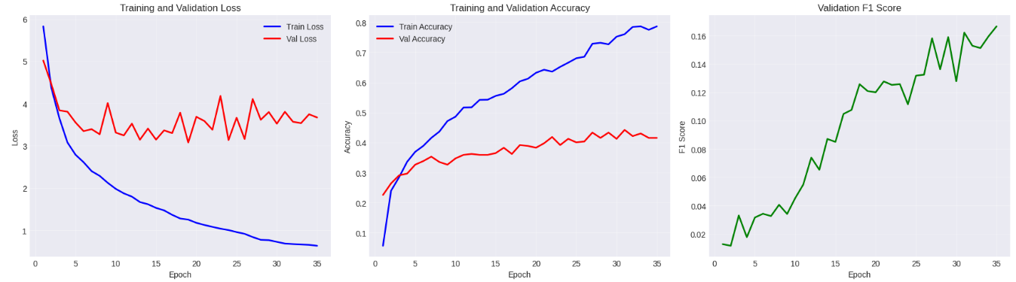
Figure 4 Loss Curve / Accuracy /F1 score Comprarison of Baseline Classifier
The model’s training accuracy rate is 78.65% in Table 6, proving that the baseline architecture has the basic ability to handle medical VQA tasks. The training process converges stably, and the training loss is controlled at a low level of 0.6623, indicating that the optimization algorithm configuration is reasonable and the model can effectively extract features from the training data. However, the model exhibited a severe overfitting phenomenon, with a training-test accuracy gap as high as 44.82%, verifying that its generalization ability on unseen data was significantly insufficient. All kinds of evaluation indicators are generally low (F1 score 13.64%, accuracy 33.83%, recall 13.27%), reflecting a serious category imbalance problem that affects the prediction quality.
Table 6 Core training parameters of baseline model
Metric | Training Set | Validation Set | Test Set
Accuracy | 78.65% | 44.21% | 33.83%
F1 Score | - | 16.21% | 13.64%
Precision | - | 16.04% | 14.54%
Recall | - | - | 13.27%
Loss | 0.6623 | 3.8041 | -

Figure 5 shows that the model has the highest accuracy rate (48%) on CLOSED problems, but the overall performance indicators (F1, precision, recall) are all at a relatively low level (about 13%-14.5%). This indicates that the model performs slightly better in judging simple problems, but its overall performance in comprehensive evaluations is poor, and its generalization ability is relatively .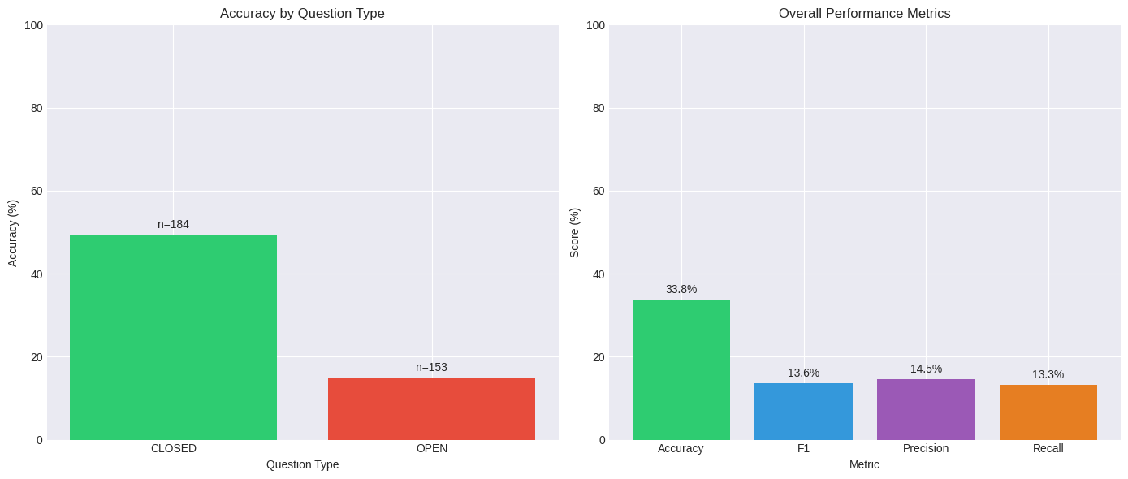
Figure 5 Accuracy by question type and overall performance on test dataset

Generative Model (Sonsbeek et al.) Result

DISCUSSION

RQ1: Performance Gap (Baseline vs VLM)

RQ2: Expression Quality & Hallucination Risk

Limitations

CONCLUSION

ACKNOWLEDGEMENT (If Required)
We would like to express our gratitude to XXX for her assistance in XXX.

AUTHORS CONTRIBUTION

REFERENCES

APPENDIX

